Invoice
Flourtown, PA 19031
215.233.3663
INVOICE# | DATE
9187 | 5/22/2013

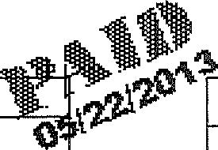
VEHICLE INFORMATION

2005 Volvo SW
Vin#
Miles:

P.O. NO.
DESCRIPTION |  | AMOUNT
PA State Inspection |  | 27.00T
Emissions Inspection |  | 53.70T
Lube, Oil, Filter - |  | 36.95T
Mechanical Labor replace front struts |  | 204.00T
Parts 2 front struts 215.69x2 |  | 431.38T
Mechanical Labor replace rear shocks |  | 221.00T
Parts rear shocks 145.71 x 2 |  | 291.42T
Mechanical Labor replace motor mount |  | 85.00T
Parts motor mount |  | 68.26T
Sublet/Misc. wheel align |  | 99.95T
check all tires rebalance & rotate |  | 72.00T
shop supplies |  | 20.00T
Hazardous Waste Removal |  | 3.00T
PA Sales Tax |  | 96.82
Thank you for your business. | Total $1,710.48

Invoice
INVOICE# | DATE
9135 | 4/10/2013
Flourtown, PA 19031
215.233.3663

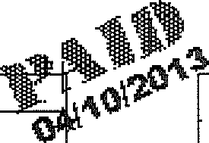
BILL TO
VEHICLE INFORMATION
Volvo SW
Vin#
Miles:

.O. NO.
DESCRIPTION | AMOUNT
Mechanical Labor replace RR bulb  Parts  PA Sales Tax | 10.00T  2.00T  0.72
Total $12.72

Invoice
INVOICE# | 1 DATE
8722 | j 5/18/2012
Flourtown, PA 19031
215.233.3663

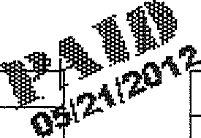
BILL TO
VEHICLE INFORMATION
2005 Volvo XC70
Vin# YV1SZ592151204592
Miles:92257

P.O. NO.
DESCRIPTION |  | AMOUNT
Front Brake Rotors |  | 158.00T
Front Brake Pads |  | 74.98T
Mechanical Labor |  | 127.40T
Front Tires***Pirelli Scorpion***215/65/R16 |  | 355.00T
Mount and Balance |  | 36.00T
Tire Disposal |  | 5.00T
Tire Tax |  | 2.00
Lube, Oil, Filter |  | 36.95T
Hazardous Waste Removal |  | 2.00
PA State Inspection |  | 27.00T
Emissions Inspection |  | 53.70T
PA Sales Tax |  | 52.44
 | Total $930.47

Invoice
INVOICE# | DATE
8239 | 5/25/2011
Flourtown, PA 19031
215.233.3663

BILL TO
VEHICLE INFORMATION
Volvo SW

P.O. NO.
DESCRIPTION |  | AMOUNT
PA State Inspection |  | 27.00T
Emissions Inspection |  | 53.70T
PA Sales Tax |  | 4.84
Thank you for your business. | Total $85.54

Invoice
INVOICE# | 1 DATE 1
7420 | I 12/29/2009 [
Flourtowiij, PA 19031
215.233.3663

BILL TO
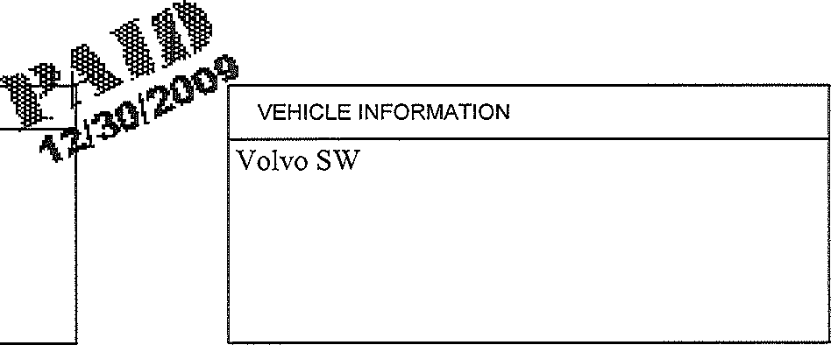
P.O. NO.

DESCRIPTION |  | AMOUNT
Mechanical Labor |  | 40.00T
Parts 2 tire 139.95 |  | 279.90T
Disposal |  | 4.00T
2 tire tax |  | 2.00
Mechanical Labor replace rear brake & rotors |  | 125.00T
Parts brake pads |  | 72.50T
Parts 2 rotors 66.85 |  | 133.70T
Hazardous Waste Removal |  | 3.00T
PA Sales Tax |  | 39.49
Thank you for your business. | Total $699.59

Invoice
INVOICE# | DATE 1
7414 | 12/22/2009 |
Flourtown, PA 19031
215.233.3663

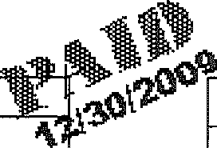
BILL TO
VEHICLE INFORMATION
Volvo SW

P.O. NO.

DESCRIPTION
AMOUNT
Mechanical Labor
Parts 2 tires 139.95
Hazardous Waste Removal
Tire Tax
PA Sales Tax
279.
4.
2.

$345.33
Total
Invoice
INVOICE# | DATE 1
6152 | 9/28/2007 |
Flourtown, PA 19031
215.233.3663

BILL TO
VEHICLE INFORMATION
Volvo SW

P.O. NO.

DESCRIPTION
AMOUNT
2 Tires 139.95x2
Mechanical Labor
2 Tire Tax
Hazardous Waste Removal
PA Sales Tax
279.90T
29.90T
2.00
18.86

$335.16
Total
Invoice
INVOICE# | DATE |
5955 j | 6/5/2007 |
Flourtown, PA 19031
215.233.3663

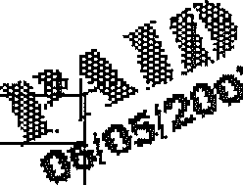
BILL TO
VEHICLE INFORMATION
2005 Volvo SW

P.O. NO.

DESCRIPTION
AMOUNT
PA State Inspection
Emissions Inspection
PA Sales Tax
27.
53.

$85.54
Total

invoice
Flourtown., PA 19031
215.233.3663
INVOICE# | DATE
5423 | 6/29/2006

BILL TO
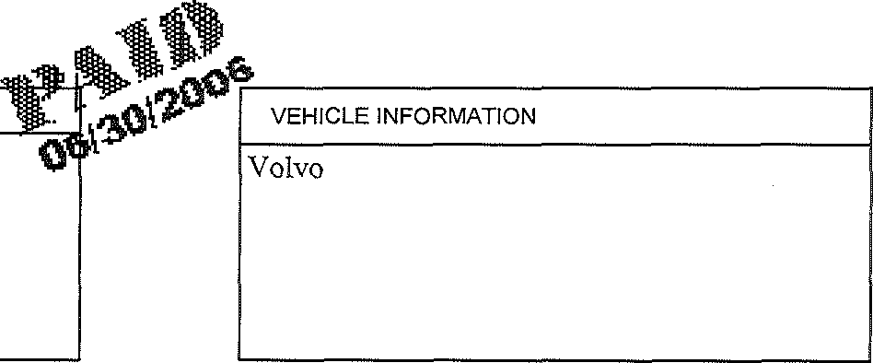
P.O. NO.

DESCRIPTION
AMOUNT
PA State Inspection
Emissions Inspection
PA Sales Tax
27.
53.

$85.54
Total

